**Newton’s Second Law Problem Solving**

Level 1: One dimension, no friction formulas

1. A 68 kg skydiver falls from an airplane. The drag force on his body is 0.85 times his weight. (a) Draw a free body diagram for the skydiver. (b) Find his acceleration.

‘

1. A 1800kg elevator is lifted using a motor and cable. (a) Draw a free body diagram for the elevator. (b) Find the tension in the cable given that the elevator is lifted with an acceleration of 0.5m/s2.

1. Kenny catches a fish and pulls it straight up out of the water with an acceleration of 4.5 m/s2 using a fishing line that can withstand a maximum of 22 N of tension. The line breaks and the fish gets away. What is the mass of the fish? Explain why this is the minimum possible mass.

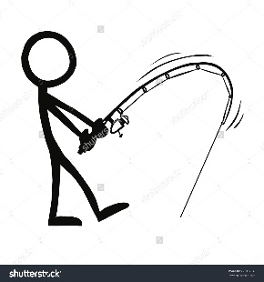

1. A 10kg bucket is lowered by a rope in which there is 63 N of tension. What is the acceleration of the bucket? Is it speeding up or slowing down? Why?

Level 2: 2 Dimensions, no friction formulas

1. Study the diagram below and determine the acceleration of the box and its final velocity. after being pulled by the applied force for 2 s.

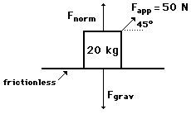

1. You drag your best friend in a sled (total mass of 65.0 kg) horizontally across frictionless snow with a force of 50.0N. The force you apply to the sled makes a 35.0° angle with the horizon. What is the sled’s acceleration? (hint – break angled vectors into components)